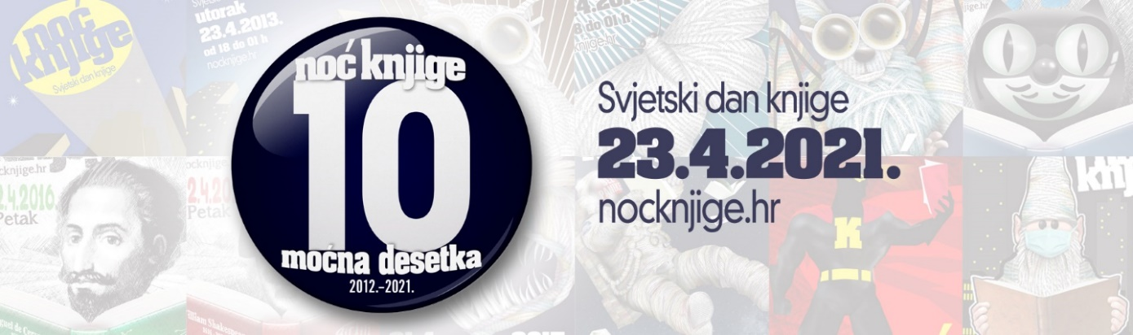
Tema Noći knjige 2021.: LJEKOVITA MOĆ KNJIGE

***Koja je knjiga za Vas bila ljekovita i iscjeljujuća i zašto?***

____________________________________________________________________________
___________________________________________________________________________
____________________________________________________________________________
____________________________________________________________________________
____________________________________________________________________________
____________________________________________________________________________
____________________________________________________________________________
____________________________________________________________________________
___________________________________________________________________________

Ime i prezime (nije obavezno): ________________________________________

